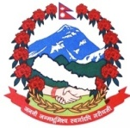थुलुङ दुधकोशी गाउँपालिका

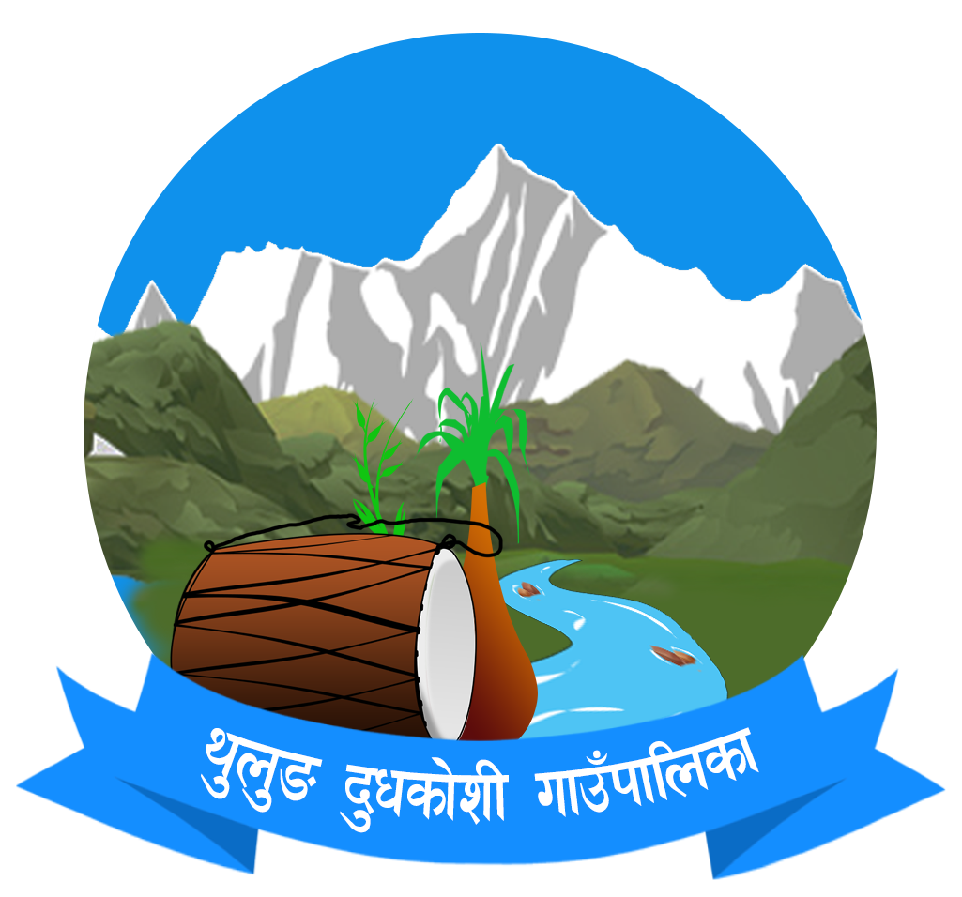

मुक्ली सोलुखुम्बु¸ प्रदेश नं. १¸ नेपाल

Thulung Dudhkoshi Rural Municipality

Mukli, Solukhumbu, 1 No. Province, Nepal

परिक्षा समिति

EXAMINATION COMMITTEE

**प्रमाणपत्र**

**CERTIFICATE**

श्री .................................................................. ले ................................... बाट विक्रम सम्बत................ को परिक्षा समितिद्धारा सञ्चालित आधारभुत तह (कक्षा ८) को परिक्षामा सहभागी भई ....................... ‌औसत स्तरीकृत अंक प्राप्‍त गरेको प्रमाणित गरिन्छ ।

This is to certify that Mr./Ms. …………………. of …………………………. has completed Basic Level Examination (Grade VIII) conducted by Examination Committee in the year …………. A.D. with ……………… Grade Point Average (GPA).

EDUCATION OFFICER

Date: